Social Media Sentiment Analysis Report
- Introduction
This report provides a detailed, in-depth analysis of Social Media Sentiment factors such as Engagement Trends, user demographics, sentiment posts trends, and Post Types. By using analytics tools like SQL and Power BI, the analysis carried out shows and uncovers certain behavioural trends of users, which will help tremendously to increase engagement with social media platforms. This report, which is detailed and well-ordered information from the analysis, will also help by providing intriguing, and amazing insights based on the analysis carried out
- Objectives
The main objectives of the analysis carried out on social media sentiments are:
- To identify times (hourly and overall overtime) in which posts tend to get more engagements
- To uncover the sentiment pattern for all post types
- To analyze the engagement rate with different post types
- To identify how followers count relates to sentiment label
- To give recommendations for improving engagements and follower count across different social media platforms
- Data collection and Transformation
The analysis was carried out using a dataset obtained from Kaggle. The original and actual data before cleaning and analysis contained information about posts made, user follower counts, engagement rate, date and time the post was made, and sentiments attached to the posts.
Steps taken towards transforming the data were as follows:
Data Cleaning: The dataset was cleaned in SQL using the Microsoft SQL server in Visual Studio Code. Although there were no duplicates, some data formats needed to be changed, such as replacing some values with their full form, separating the date and time columns, eliminating redundant columns, and many more. There were however no missing values.
Data Preparation: This stage was done in Power BI. This tool was used to create new columns to perform calculations and enhance the reach of the analysis. Some columns are Post Date, Post Time, Total Engagements, Average Engagements, Day of Week, and so on.
Data Visualization: Power BI was then used to perform interactive data analysis, by using several visualizations to identify trends in social media sentiments
- Methodology:
The following methodology included the following key steps:
- Engagement Analysis: an in-depth analysis of engagement was carried out to understand the pattern in which user engagement patterns. This analysis included analyzing sentimental posts, finding the engagement trend over time, weighing different factors that correlate with the user's follower count and many more. Visualizations such as column charts, bar charts, line charts, and pie charts were used to visually represent these trends and discover insights from them
- EDA (Exploratory Data Analysis): Descriptive statistical charts and methods were used to uncover trends in several aspects of the social media dataset
- User Segmentation: The Social media users were grouped based on post type, engagements, follower count, and sentiment labels to identify significant trends in the data and draw insights.

- Key Findings
- Engagement Trends by Post Type:
The highest engagement was on image posts (rounding up to 0.58 million interactions), followed by video posts (0.57 million) and text posts (0.56 million). This means that visual content outperforms text-based posts by a fairly small margin.
- Sentiment Distribution by Post Type:
Most of the image posts had a slight bias towards positive sentiment (245 posts) vs neutral (235) and negative (204). A balance in the spread of sentiment on Video posts compared to normal posts was seen, with a bit fewer neutral videos. All sentiment types saw a fairly equal number of text posts.
- Follower Count by Sentiment:
Though there were slightly more total followers associated with positive sentiment posts (34.43%), we also had 34.34% of followers associated with neutral and 32.23% associated with negative sentiment posts. Such a condition would make us find that positive sentiment contributes a notwithstanding high insight follower engagement.
- Engagement by Day of the Week:
Thursday (259K) and Monday (257K) saw the highest engagement whereas Tuesday holds the lowest (224K). The start and end of the work week are predicted to indicate the optimal times to post content in order to get the most engagement.

Dashboards and KPIs
Dashboards
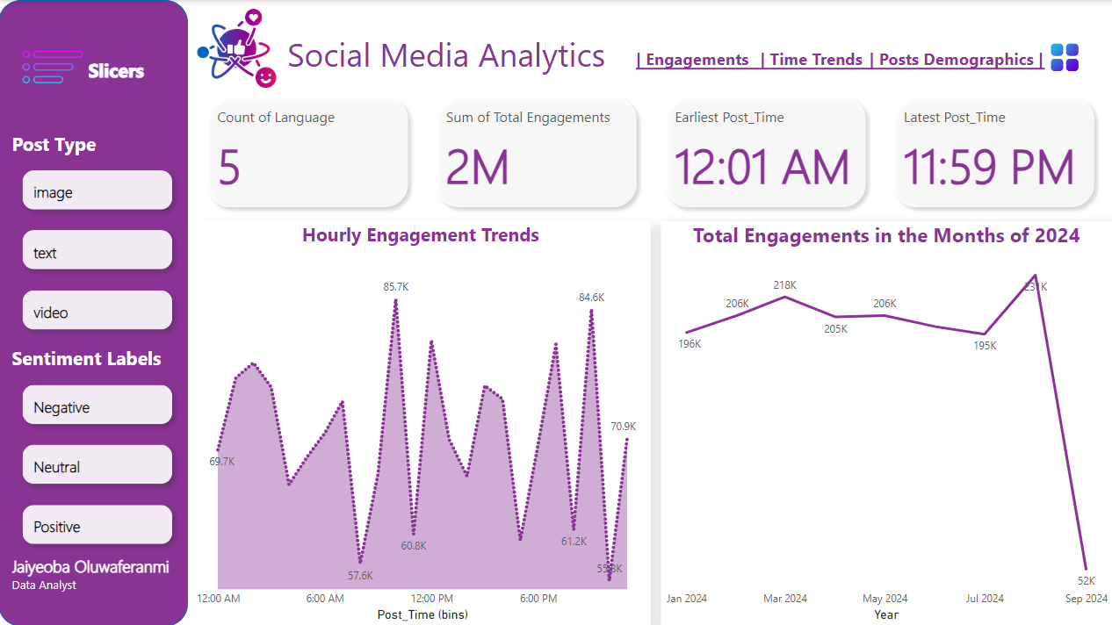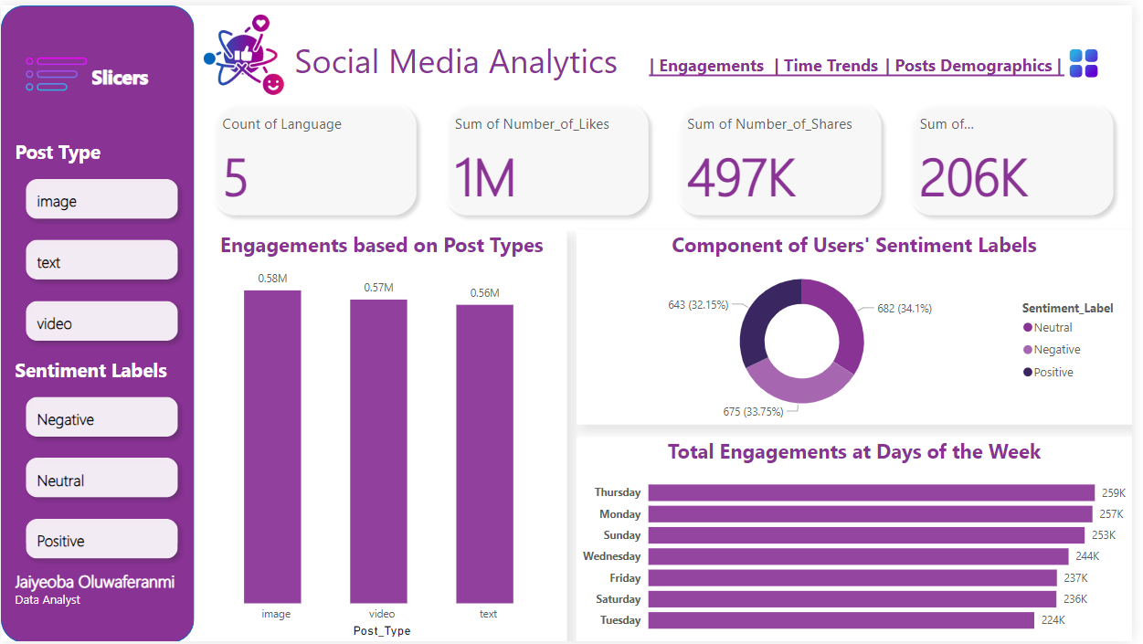
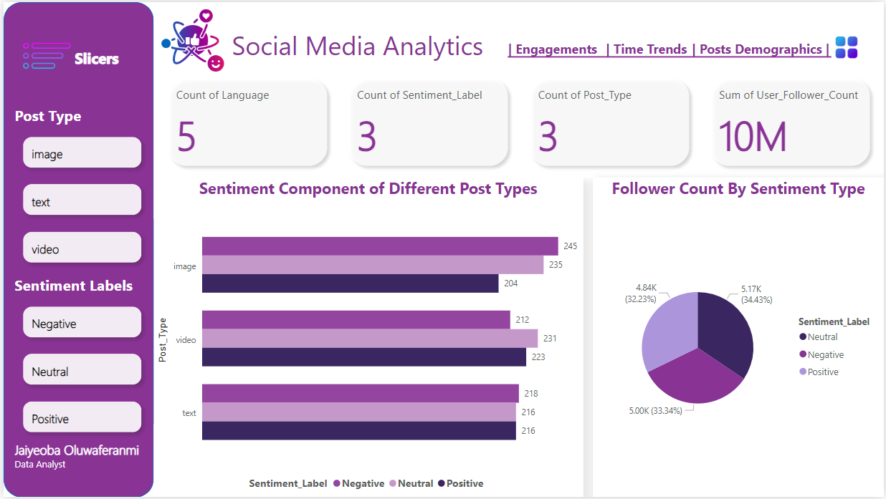
KPIs
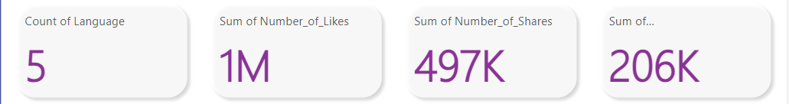
- Recommendations
  - Increase Visual Content:
As images and videos have higher engagement compared to text, they should be prioritised so you can get better interaction rates.
  - Post at High-Engagement Times:
Instead of posting all the content on that week, concentrate on posting content on Thursdays and Mondays when the engagement on the posts is higher. Tuesdays have the least engagement.
  - Encourage Positive Sentiment:
Positive sentiment content has slightly higher followers and engagement. Having positive sentiment strategies can include shifting to positive sentiment promoting uplifting messages or visuals.
  - Optimize for Follower Growth:
Since follower count is correlated to sentiment, especially positive and neutral sentiment, you can try to post to spur favourably higher growth in follower count.
  - Refine Content Strategy by Sentiment for Each Post Type:
Make sure content serves the sentiment trends in each post type. Something like image posts with a positive sentiment could be promoted, they tend to have higher follower counts.

- Conclusion
This analysis gives a critical data analysis of the social media engagement trends, distribution of the sentiment and the behaviour of the followers. The most interesting findings are that visual content drives the highest amount of engagement, and follower growth is slightly more correlated with positive sentiment. According to engagement trends, Thursdays and Mondays are the best days to post to get the most reach. Now you can use these insights to leverage social media strategy to gain more engagement, optimise for content timing, and grow pools of followers across platforms. Keep running sentiment analysis and engagement monitoring regularly to optimise.

